**经济学人:为什么海龟吃塑料垃圾 2020-07-04**

Turtles have an **unfortunate** habit of devouring **plastic** objects floating in the sea.

海龟有一个坏习惯，就是吞食漂浮在海里的塑料制品。

These then get snared in their alimentary canals, cannot be broken down by the animals' digestive enzymes and may **ultimately** kill them.

然后这些东西会陷入消化道，无法被动物的消化酶分解，并最终可能致死。

It is widely **assumed** that this **penchant** for plastics is a matter of mistaken **identity**.

人们普遍认为，这种对塑料的嗜好是一种错误的识别。

Drifting **plastic** bags, for instance, look similar to jellyfish, which many types of turtles love to eat.

例如，漂浮的塑料袋看起来就像许多海龟喜欢吃的水母。

Yet lots of **plastic** objects that end up inside turtles have no **resemblance** to jellyfish.

然而，海龟体内的许多塑料制品却与水母毫无相似之处。

Joseph Pfaller of the University of Florida therefore suspects that something more **complicated** is going on.

因此，佛罗里达大学的Joseph Pfaller怀疑，更复杂的事情正在发生。

As he writes in Current Biology, he thinks that the odour of marine micro-organisms which colonise floating **plastic** objects induces turtles to feed.

他在《Current Biology》中写道，海洋微生物附着在漂浮的塑料物体上，它们的气味诱使海龟进食。

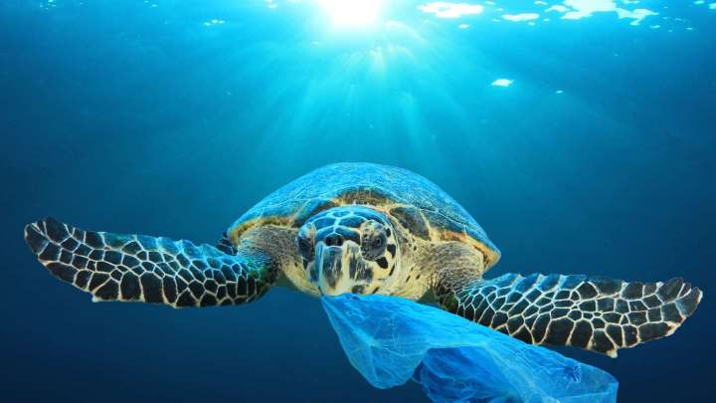

The idea that the smell of **plastic** flotsam might lure animals to their doom first emerged in 2016.

塑料垃圾的气味可能会导致动物灭亡的想法最早出现在2016年。

Researchers at the University of California, Davis, noticed that **certain** chemicals, notably dimethyl sulphide,

加州大学戴维斯分校的研究人员注意到，某些化学物质，

which are released into the air by micro-**organism**-colonised plastics, are those which many seabirds sniff to **track** down food.

尤其是被微生物占领的塑料释放到空气中的二甲基硫化物，是许多海鸟用来寻找食物的。

These chemicals mark good places to hunt because they **indicate** an **abundance** of the algae

这些化学物质标记了捕食的好地方，因为它们表明在海洋食物链的底部

and **bacteria** that lie at the bottom of marine food chains. The researchers also found that birds

有大量的藻类和细菌。研究人员还发现，

which **pursue** their food in this way are five or six times more likely to eat **plastic** than those which do not.

以这种方式捕食的鸟类比不以这种方式捕食的鸟类吃塑料制品的可能性要大5到6倍。

Since turtles are known to break the surface periodically and sniff the air when navigating towards their feeding areas,

众所周知，海龟在游向觅食区域时，会周期性地破开水面，并嗅空气中的气味。

Dr Pfaller theorised that they are following these same chemicals, and are likewise fooled into thinking that floating **plastic** objects are **edible**.

因此，Pfaller博士推断，海龟也在遵循着这些相同的化学物质，而且同样会误以为漂浮的塑料物体是可以食用的。

To test that idea, he and his colleagues set up an experiment involving loggerhead turtles, a **species** frequently killed by **plastic**.

为了验证这个想法，他和他的同事们做了一个实验，实验对象是经常被塑料杀死的红海龟。

They arranged for 15 of the animals, each around five months old, to be **exposed**, in **random** order,

他们安排了15只动物，每只大约5个月大，按照随机的顺序，让它们闻四种气味，

to four odours delivered through a pipe to the air above an **experimental** **arena**.

这些气味通过管道输送到实验场地上方的空气中。

The odours were: the vapour from deionised water; the smell of **turtle**-feeding pellets made of shrimp and fish meal;

这四种气味是：去离子水的蒸汽；由虾和鱼粉制成的喂海龟的小丸的味道

the smell of a clean **plastic** bottle chopped up into ten pieces;

一个被切成10块的干净的塑料瓶的味道；

and the smell of a similarly chopped bottle that had been kept in the ocean for five weeks to allow algae and **bacteria** to grow on it.

以及类似被切块的瓶子的味道，这个瓶子在海洋里漂了五周，上边长满了海藻和细菌。

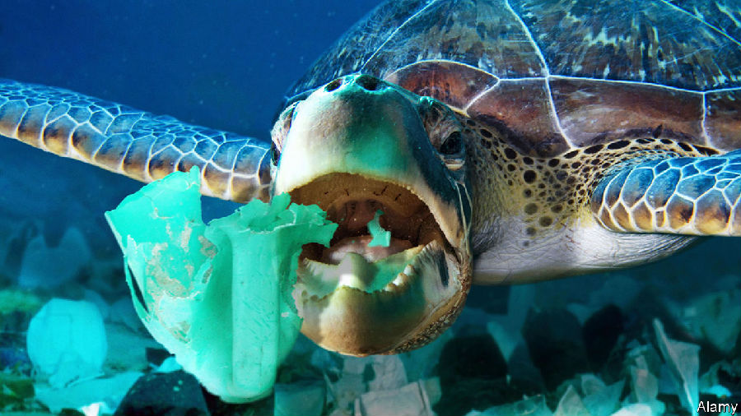

Two of the smells proved far more **attractive** to the animals than the others.

事实证明，其中两种气味对动物的吸引力要比其他气味大得多。

When sniffing both the odour of food pellets and that of five-week-old bottles

当海龟闻食物颗粒的气味和那个五周瓶子的气味时，

turtles kept their nostrils out of the water more than three times as long,

它们鼻子离水时间是闻到新鲜塑料瓶或去离子水蒸汽气味时的三倍，

and took twice as many breaths as they did when what was on offer was the smell of fresh bottle-**plastic** or deionised-water vapour.

呼吸的次数是闻到新鲜塑料瓶或去离子水蒸汽气味时的两倍。

On the face of it, then, the turtles were responding to the smell of old bottles as if it were the smell of food.

从表面上看，海龟对旧瓶子的气味的反应就像闻到食物的气味一样。

Though they have not yet tested whether dimethyl sulphide is the culprit,

尽管他们还没有测试过是否二甲基硫化物是罪魁祸首，

Dr Pfaller and his colleagues think it is the most likely **candidate**.

但Pfaller博士和他的同事认为它是最有可能的候选者。

In an unpolluted ocean, pretty well anything which had this smell would be **edible**—or, at least, **harmless**.

在一个没有污染的海洋里，任何有这种气味的东西都是可以食用的——或者至少是无害的。

Unfortunately, five-week-old **plastic** bottles and their like are not.

不幸的是，漂浮五周的塑料瓶和类似的东西却不是。