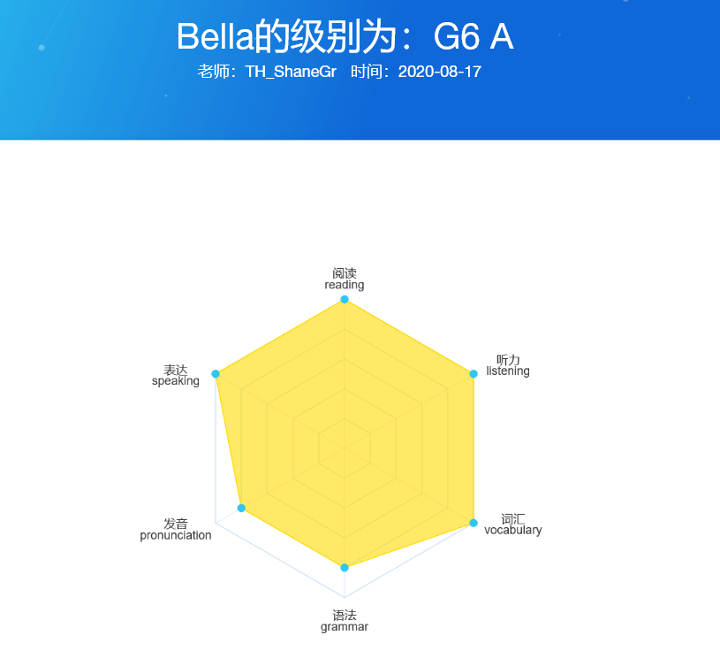

* **阅读**reading

**评分结果**

阅读理解能力优秀，能结合老师的提问对文章内容做深度思考。

**老师评语**

It is imperative to encourage her reading of English books. The books should be age and level appropriate. Many children like to read the same book over and over, however they need to vary the books they are reading in order to learn new phrases, colloquial terms, idioms, and sentence patterns, as such one book is not sufficient as the singular reading election. I suggest that she reads at least 12 full English chapter books per year, this will broaden her vocabulary, reading, and speaking abilities at once. Level: G6A ----Missed words: almost. ----Intonation: good intonation ----Pauses: normal pauses ----Comprehension: She answered the comprehension questions without referencing the text, this indicates that she read for deeper comprehension. ----Questions: 3/3 Lastly, she is excellent at reading. When reading, intonation is very important, it’s what makes the listener feel like they are engrossed in the story. When reading at higher levels the listener uses intonation to identify the emotional context of the story. It’s very important to read with good intonation, to pause at commas and periods, and to vary emotion when reading. She does this and should feel very proud of herself!

* **听力**listening**评分结果**
* 能理解正常语速的英文。

**老师评语**

Listening is an invaluable skill that should be honed like anything else. She needs to listen to English in many accents. I suggest US, Canadian, UK, and Australian/New Zealand accents. These are the most widely spoken accents, mastering these will allow her to excel anywhere in the world. She can listen to these accents in movies, music, documentaries, and live in English classes here at Whales. She can listen very well and has a high level of understanding of the English language. She can function well with spoken English. She functions well with English spoken at a moderate pace and does not need things repeated or rephrased. She can also grasp details and important information as presented . Her answers are almost always timely and appropriate. Lastly, she did not need me to repeat at all. This indicates a higher level of English ability. However, it is important to continue to improve, one of the most efficient ways to continually improve listening ability is to have the student listen to movies or music in English – this will not only develop her listening skills, but it will also acclimate her to different cadences, accents, and colloquial terms used by native English speakers.

**词汇**vocabulary**评分结果**

能结合上下文，准确使用大量高级词汇，并对各项词汇技能展示出优秀的理解和运用能力。

**老师评语**

Vocabulary is indispensable and should be considered a priority when learning any language. Vocabulary is what establishes the student as a decent English speaker or a phenomenal English speaker. Daily exercises should be considered in the form of new words that are level appropriate for the student. It is best to have her fuse her vocabulary and grammar skills by composing new sentences and stories daily, using her newly acquired vocabulary words. Her vocabulary is average for G6A, for her level. She has a good handle on many elementary vocabulary words. She makes good word choices when speaking. Still she would benefit from more exposure to different lexical groups. This will help her build her overall vocabulary range. Lastly, she can work on improving her vocabulary skills, as this is very important when learning a new language. She should try to learn new vocabulary as this will develop her into an advanced English speaker. The most efficient way to learn more vocabulary is by doing what they like to do, that may be reading, writing, listening to music, or watching movies. Some students learn better by audio and others by visual, finding the way they learn best will accelerate learning. ----Level: G6B scored 7/10 ----Level: G6A scored 8/10

* **语法**

grammar

**评分结果**

能灵活使用简单句和复杂句；表述过程中会出现一些语法错误。

**老师评语**

Grammar is what defines a speaker's native-like ability. When a student excels in this area it is easier to bring the other areas up to par. Grammar development in speaking and writing is imperative. You cannot have one without the other. It is best to not focus on rote memory, this can seem exigent, rather focus should be placed on how sentence frames work; both simple and complex. The student should be compelled to use complex sentences whenever possible. Her grammar is decent. She tries to use complete compound sentences often. She can connect ideas with linking expressions. Additionally she is usually aware of verb tenses and conjugations. She tries to use them with accuracy most of the time. Lastly, her grammar can be improved, She can work to master grammar, as this will make her more confident when speaking. This is very important when learning a new language and makes conversations clearer. Tenses are almost always difficult for students, the best way to avoid forgetting tenses and how to use them is to continually use them when speaking. There are many ways to improve grammar, finding the one that interests her most will be the key to rapid and sustained improvement.

* **发音**

pronunciation

**评分结果**

对生词存在部分发音不准确的现象，但不影响理解。重音及语调意识较好，能展示出一些连读的发音技巧。

**老师评语**

She is clear and understandable. She does stumble at times with unknown words and multisyllabic words as well. She does not say different words than those that are in the text.

* **表达**

speaking

**评分结果**

能在各种场合恰当、准确、流利地使用英语讨论各类话题。

**老师评语**

It is essential that she speaks to a native English speaker often. When a student speaks with a native speaker they learn how to properly blend words together to sound natural, how to use specific terms, and how to listen actively in order to respond in an appropriate manner. If she does not speak English for a period of time, she might begin to forget what she has learned, as such, it is critical that she speaks English at least once a week. What student expressed well during initial conversation: She was able to answer all of the introduction questions. Her sentence structure is generally pretty good. She can work on her word order a bit. Once I defined interests for her she was able to answer the question.

**综合评价**



She is a very intelligent student who is diligent and worked very hard in our test. I was very proud of her, she listened to me, responded to my questions, and extended her answers by adding evidence. She participated well in the text and did her best to do each exercise. It is enjoyable to speak to her as well. I suggest that she works on vocabulary as noted under that section header. I have also included ways that she can improve in this section. Again, she's an excellent student and I know she'll go far!